|  |  |  |
| --- | --- | --- |
| **Module Code**  **COMP5850M** | School of Computing  University of Leeds  **Coursework 1 - Report** | University of Leeds logo |

Full Name: Username:

Coursework Title: VIM Deadline Date: 09/03/2020

**Part 1: Java OpenNebula Cloud API (OCA) (10 marks)**

*Provide an explanation of the implementation of this task. The inclusion of the entire code is not required but you may include snippets if you wish.*

*VM template (1 mark)*

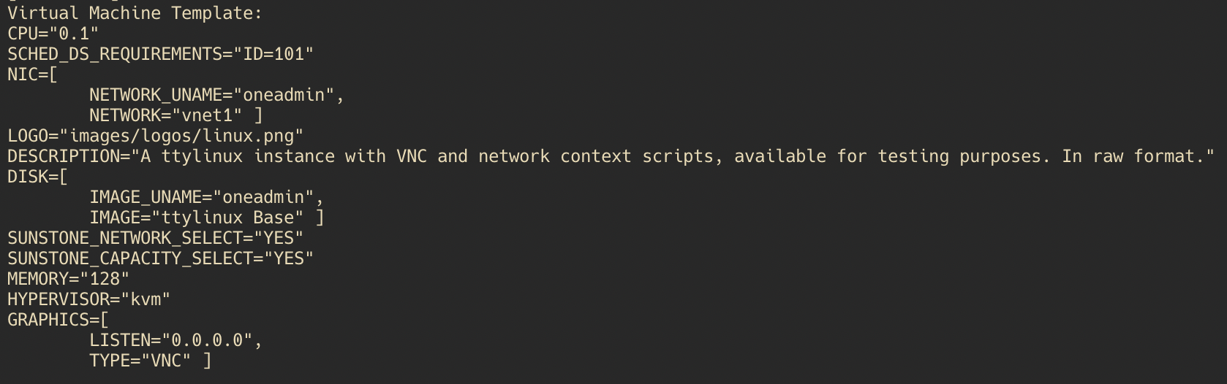

*Information OpenNebula provides about the VM (1 mark)*

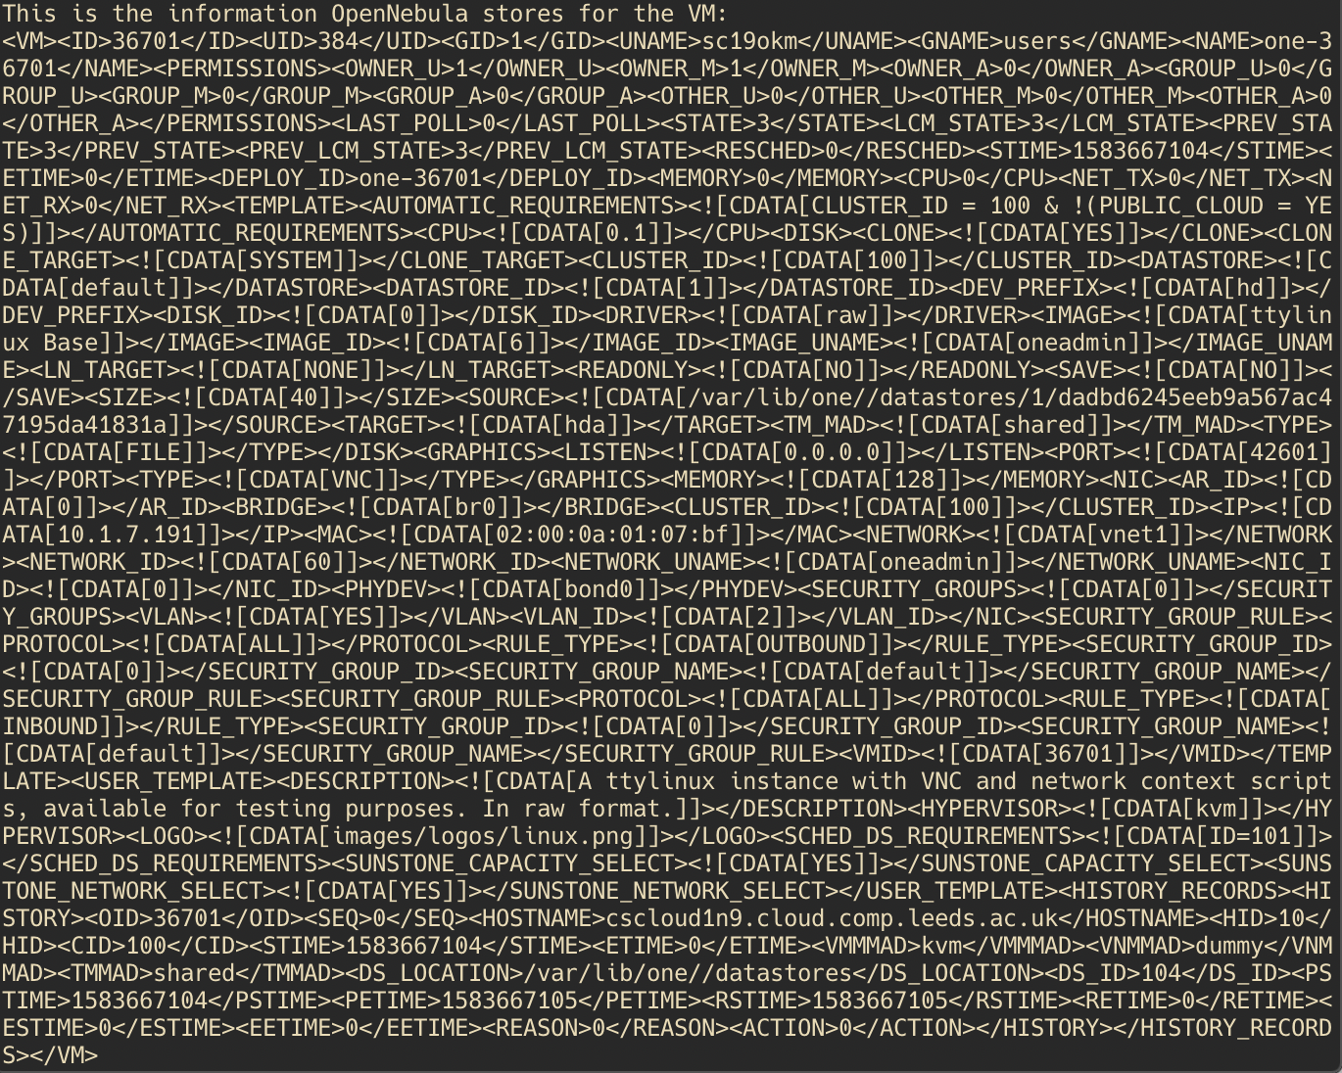

*Measure the time it takes to instantiate/delete the VM. To get these measurements you are expected to run the experiments n times (e.g. n = 5). A statistical analysis (average, standard deviation) is expected. (2 marks)*

|  |  |  |
| --- | --- | --- |
| **Run No.** | **VM instantiation time** | **VM deletion time** |
| **1** | 3957 | 8 |
| **2** | 3614 | 8 |
| **3** | 3352 | 5 |
| **4** | 3550 | 6 |
| **5** | 3325 | 6 |
| **Average** | 3559.6 | 6.6 |
| **Standard Deviation** | 227.645865 | 1.2 |

*Explain how you have obtained these measurements (2 marks)*

To calculate how long the instantiation took, I have first allocated the virtual machine. After allocation, I deployed to a host that I chose arbitrarily, which was 10 in my case. After deployment, I then wrote a loop where the system waits for the virtual machine to reach the state running, which OpenNebula has coded as “runn”. If the machine is not yet running, it waits for 10ms before trying again. I added a sleep call, as it shouldn’t affect the time too much, whilst also sending less requests to the API asking for VM info. After making sure that the VM is running, the time can then be recorded, from before allocation to the point where the VM is running. The code for the while loop looks like this:

while (!vm.status().equals("runn")) {  
 Thread.*sleep*(10);  
 rc = vm.info();  
}

As for deleting VM, the call is much more simple, as I made an assumption that the VM being deleted is already running. In that case, a simple vm.finallizeVM() call is needed. The measured time is the time it took the call finalizeVM() and return a response.

*Evidence of successful run, e.g. screenshot (4 marks)*

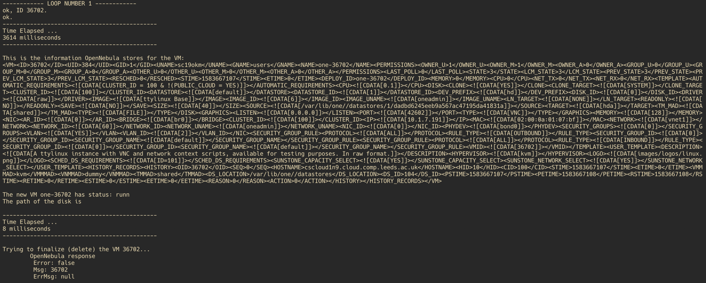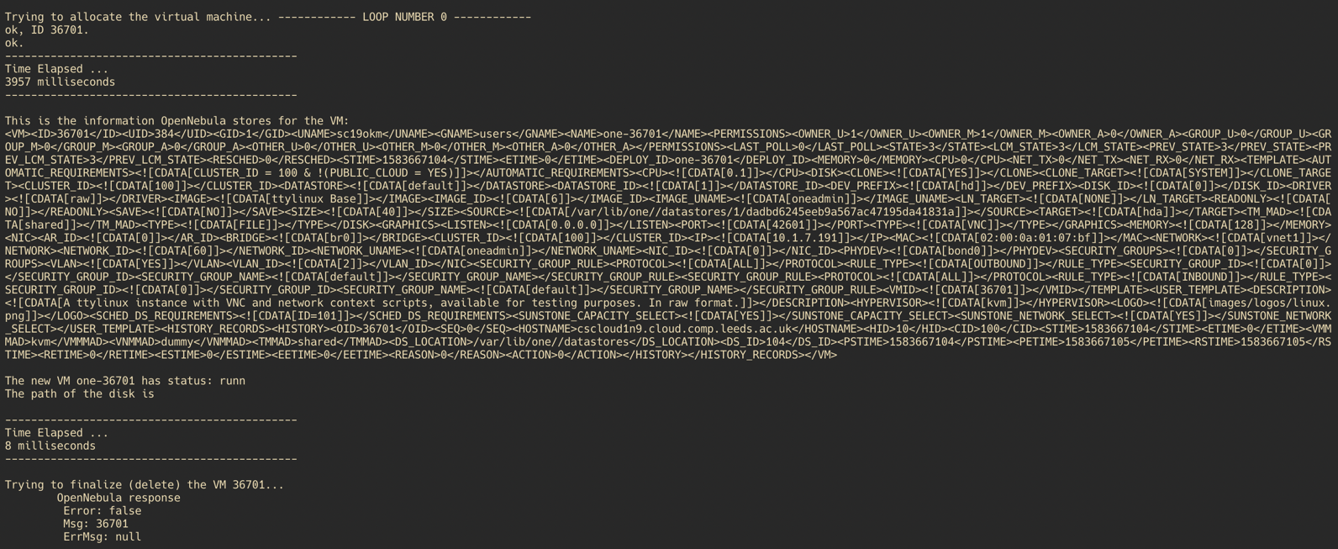

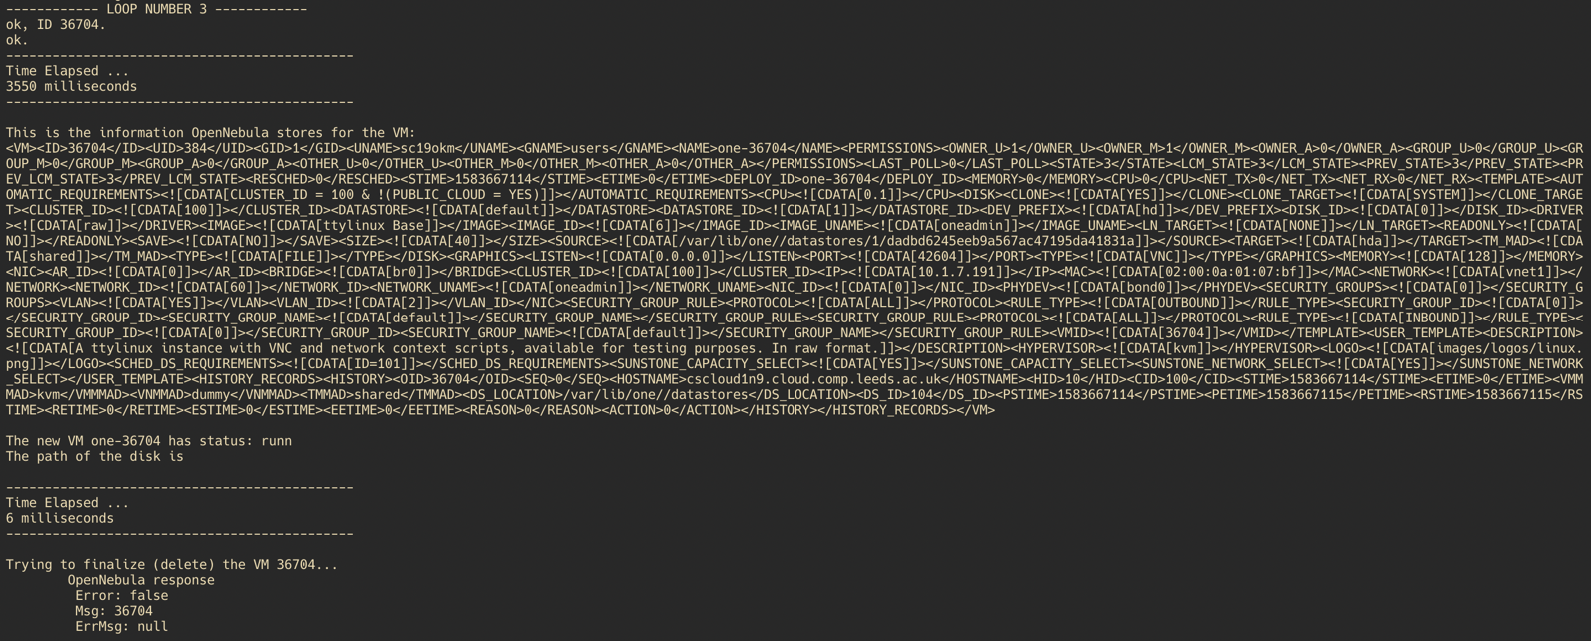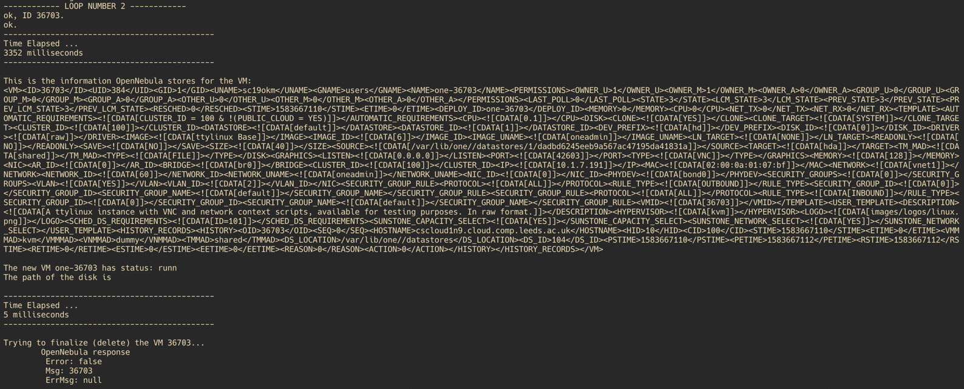

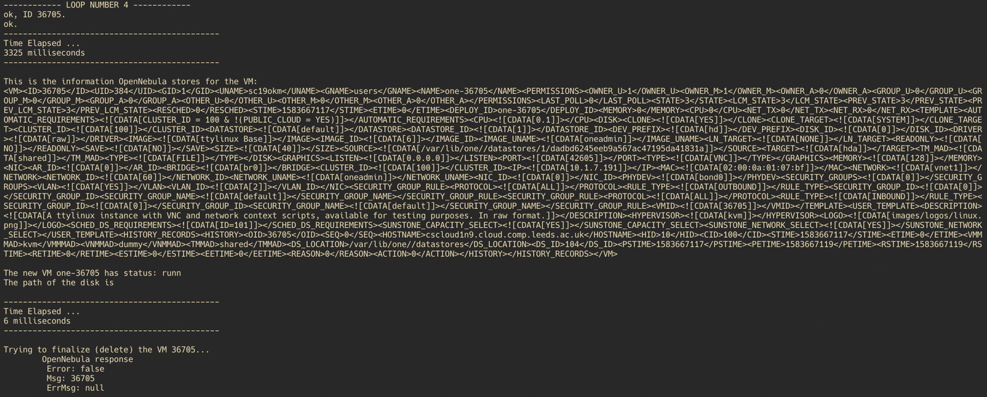

**Part 2: VM Migration (15 marks)**

*Provide an explanation of the implementation of this task. The inclusion of the entire code is not required but you may include snippets if you wish.*

*Requirements (2 marks)*

The solution needs to successfully migrate a VM to a different host, based on a heuristic. I have made an assumption that the VM is resource-heavy and requires to be moved to a host which has the least CPU usage, memory usage and disk usage. This is calculated using ‘weights’ that represent the importance of each resource. If a resource has higher weight, then the calculation will favour that resource being lower than the rest.

*Solution Design (2 marks)*

The objectives of these experiment is to see how quickly the solution migrates the VM, especially comparatively to initialisation of the VM. If the VM initialises, deletes and then initialises again quicker, then there is little point in migration. The first task however is to design a way that the VM should migrate. As described before, I will design the solution to take the various resouces of the host and check how much load they are under. This can be done using weights, where all of the values are between 0 and 1, and they must add up to 1. For this experiment, I assumed the VM is more CPU/Memory intensive, with CPU taking slight precedent, therefore I set the weights to [0.5, 0.4, 0.1] for CPU usage, memory usage, and disk usage respectively.

The overall structure will rely on getting host information first. This can be done quite easily by OpenNebula API. Once the information is retrieved, it can be stored in a data structure like an array, or a map. Then the minimum value is retrieved along with the host id. Then migration can be done quite easily by a single function call.

*Implementation (2 marks)*

*Measure the time it takes to migrate the VM. (2 marks)*

|  |  |
| --- | --- |
| **Run No.** | **VM migration time** |
| **1** | 2594 |
| **2** | 2379 |
| **3** | 2510 |
| **4** | 2345 |
| **5** | 2428 |
| **Average** | 2451.2 |
| **Standard Deviation** | 101.092532 |

*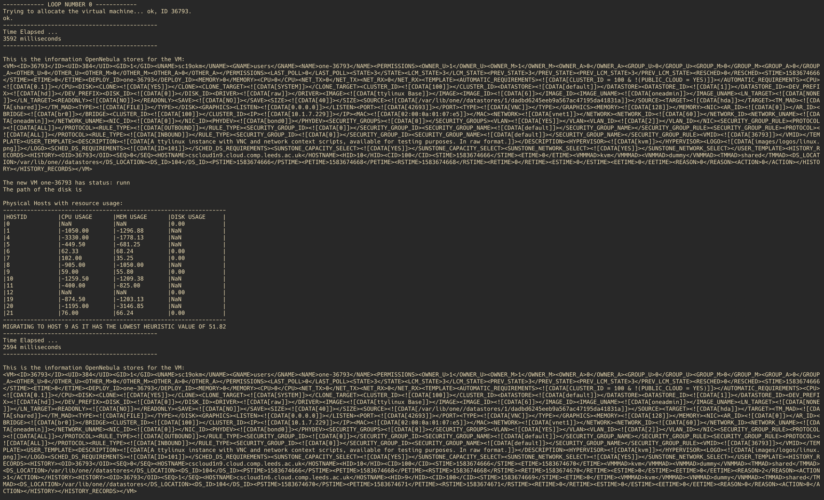Evidence of successful run, e.g. screenshot (3 marks)*

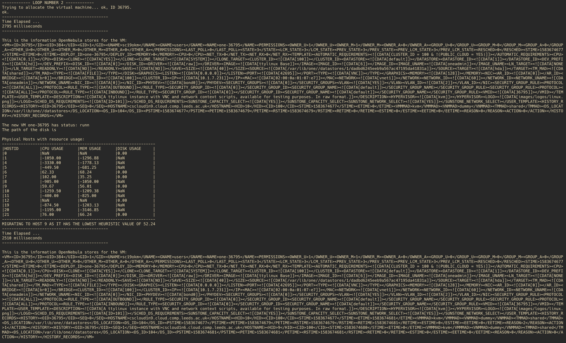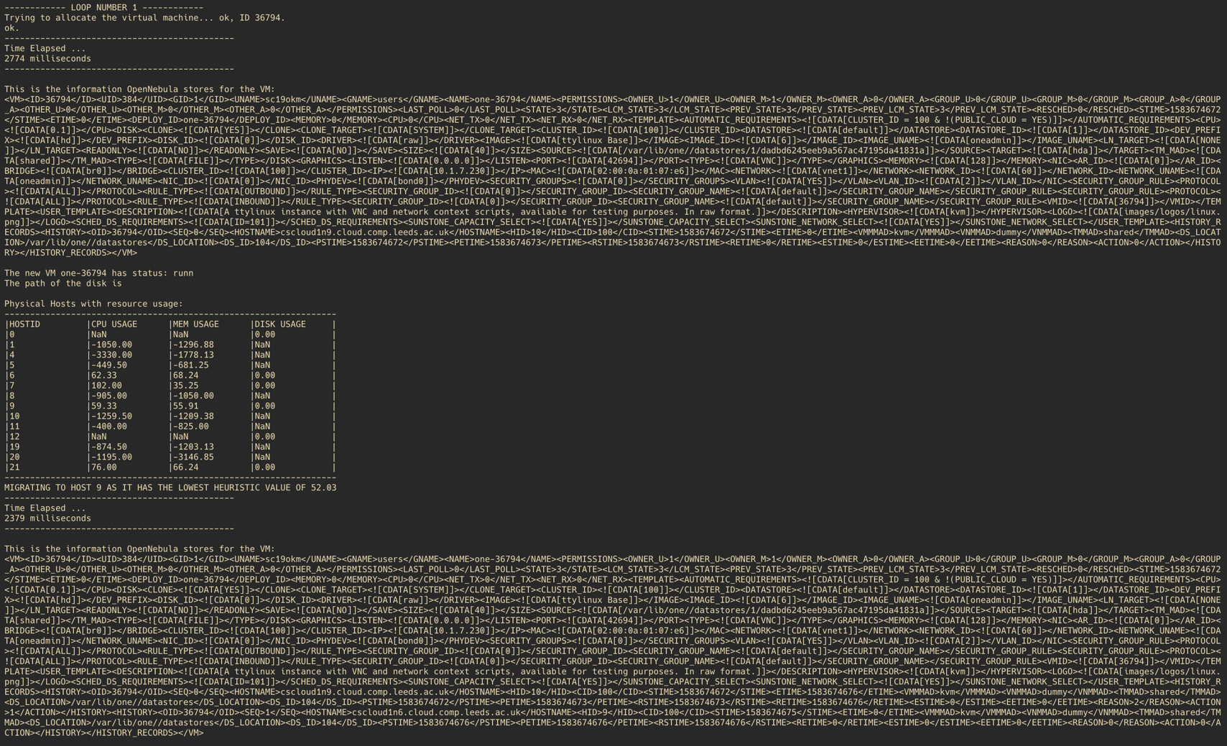

*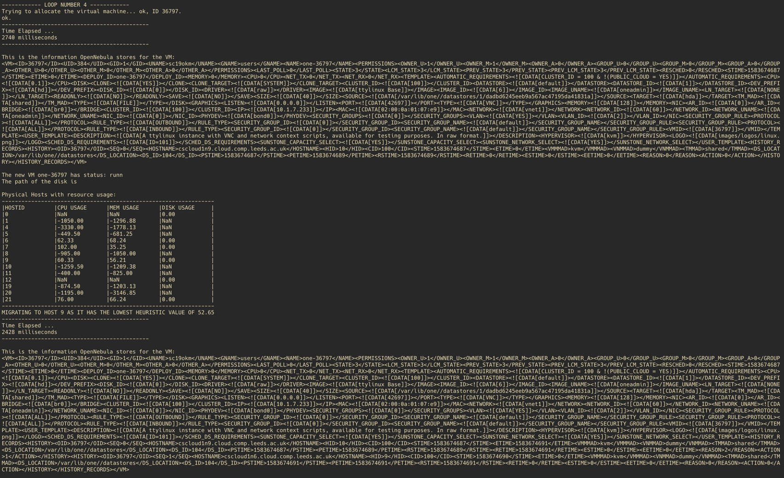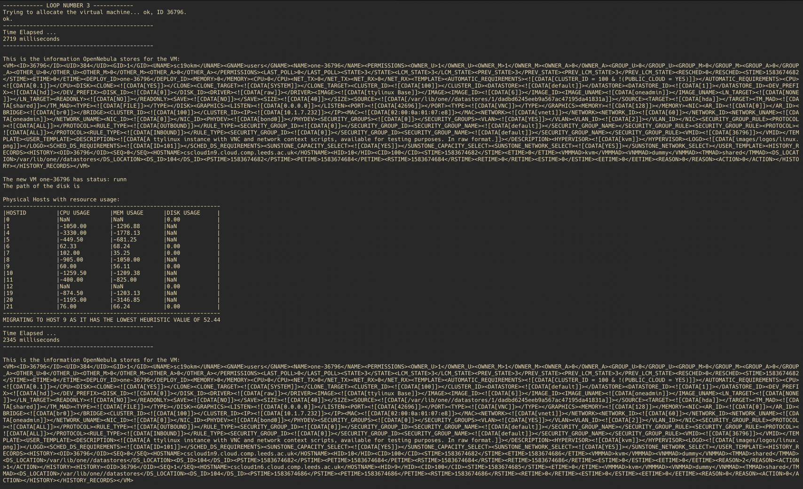Discussion of the results (4 marks)*

The results were somewhat expected as migration took considerably less time than the initialisation of the VMs. However, the information could be wrong as OpenNebula API returned strange values for usage, due to being overloaded. This, however, hasn’t impacted my migration too much, apart from ignoring the machines with incorrect values, so these machines were not considered for migration, nor should they. As you can see from the screenshots, the heuristic kept rising in value, as more machines were initialised therefore bigger load. Despite that, the algorithm managed to successfully migrate to the host with the least load, namely host 9 at the time of the experiments.

Despite the OpenNebula API returning unreliable data, the migration algorithm worked well.

**Part 3: Resource Scaling and Performance/Energy Consumption Trade-Off**

**(10 - 25 marks, depending on application and challenge)**

*Details of the application considered (stress, MPI, Hadoop, other) (1-3 marks)*

I have decided to use Hadoop, which is an implementation of the MapReduce framework. I have used Hadoop on the virtual machines that were deployed, along with the temperatures that were used in the Hadoop example. I have decided to concatenate all of the years into one huge file, measuring at 450MB. I have also used appropriate Java code to give to Hadoop.

*Design of the experiments (1-4 marks)*

The objectives of the experiments is to test how different number of virtual machines affect the time that the application needs to run, along with any power/cpu usage spikes. The experiments consist of first running a Hadoop job on a single host with a single machine. Then, after some configuration, for the Hadoop job to run on 2+ VMs.

The times of the Hadoop jobs can be measure via a Linux command or some other way, whilst other statistics, namely those about power and cpu usage can come from Zabix.

The jobs can be run multiple times to see how it affects the load of the host, along with gathering more accurate data about the experiments. This isn’t very difficult to do as it a simple bash script with a loop.

*Implementation of the experiments (1-4 marks)*

First, I have initialised all of the VMs and named them accordingly. I created a Master and Slave 1, 2 and 3. I have also created a separate VM just for the single VM/host case, as that requires slightly different config.

*Discussion of results (3-10 marks))*

**Results of Hadoop Jobs**

|  |  |  |  |  |  |  |
| --- | --- | --- | --- | --- | --- | --- |
| **Run No.** | **1 Host with 1 Virtual Machine** | **1 Host with 2 Virtual Machine each** | **2 Host with 1 Virtual Machine each** | **4 Host with 1 Virtual Machine each** | **2 Host with 2 Virtual Machine each** | **1 Host with 4 Virtual Machine each** |
| **1** | 15.8 | 22.96 | 17.43 | 18.62 | 20.61 | 18.40 |
| **2** | 18.79 | 18.46 | 19.14 | 18.78 | 24.60 | 18.35 |
| **3** | 17.03 | 17.99 | 19.36 | 18.12 | 19.16 | 19.05 |
| **4** | 17.91 | 17.99 | 20.40 | 18.23 | 19.22 | 18.25 |
| **5** | 17.15 | 19.96 | 18.81 | 19.56 | 19.01 | 18.48 |
| **Average** | **17.336** | **19.472** | **19.028** | **18.662** | **20.52** | **18.506** |
| **Standard Deviation** | **1.11030626** | **2.11075105** | **1.0731123** | **0.57063123** | **2.37034808** | **0.31532523** |

**Graphs**

**Power of a single machine**

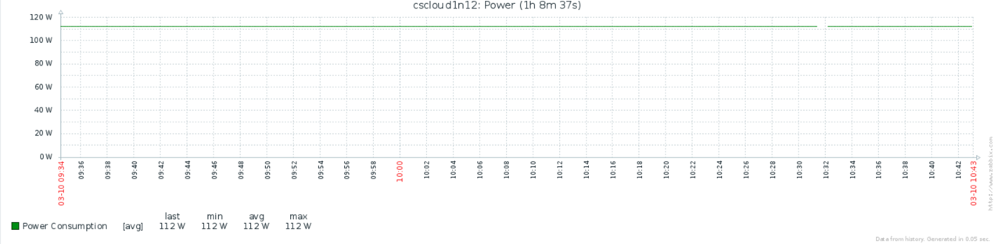

**Power for multiple VMs**

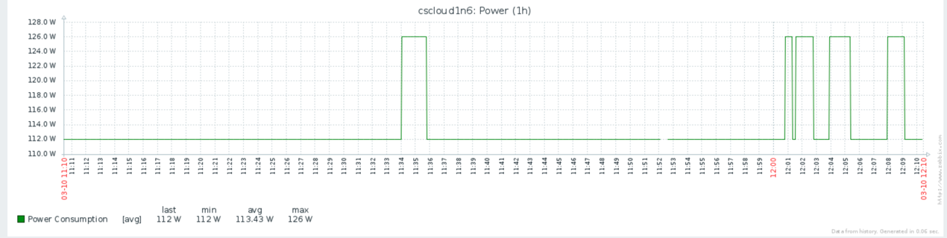

**CPU Usage 1 Host 1 VM Each**

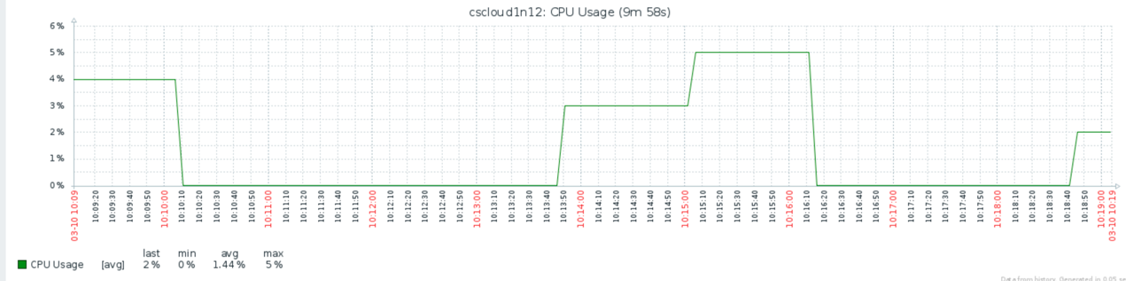

**CPU Usage 1 Host 2 VM Each**

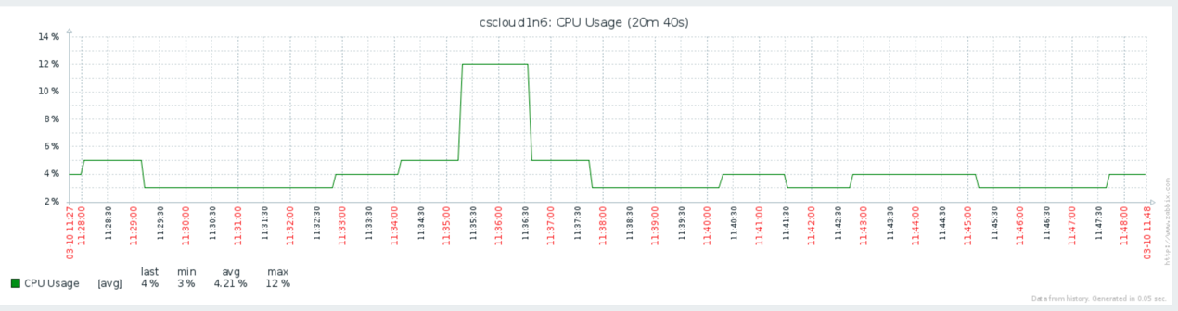

**CPU Usage 2 Host 1 VM Each**

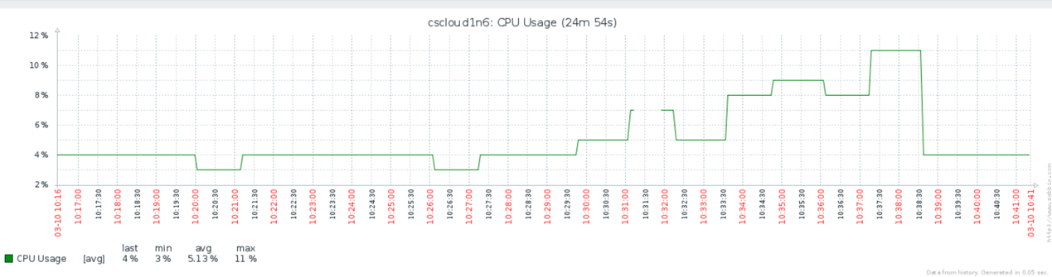

**CPU Usage 4 Host 1 VM Each**

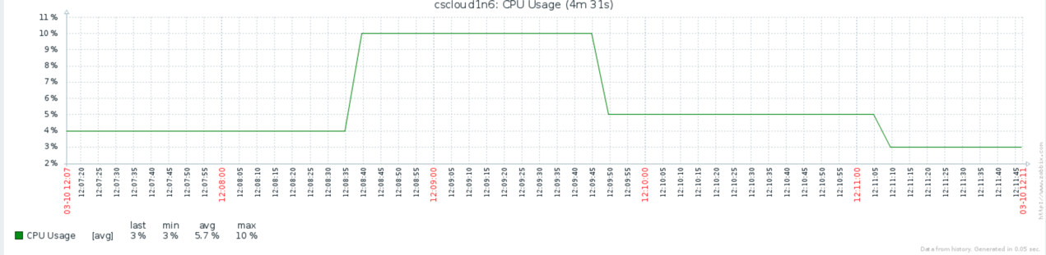

**CPU Usage 2 Host 2 VM Each**

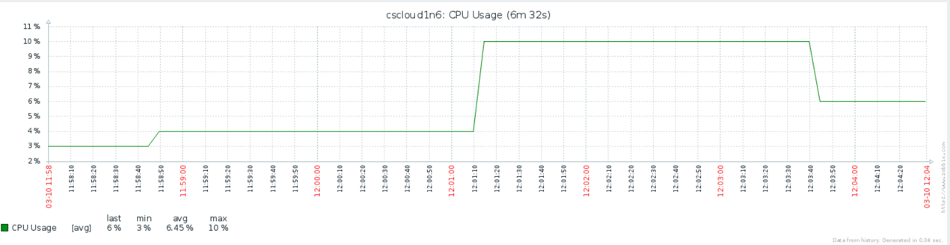

**CPU Usage 1 Host 4 VM Each**

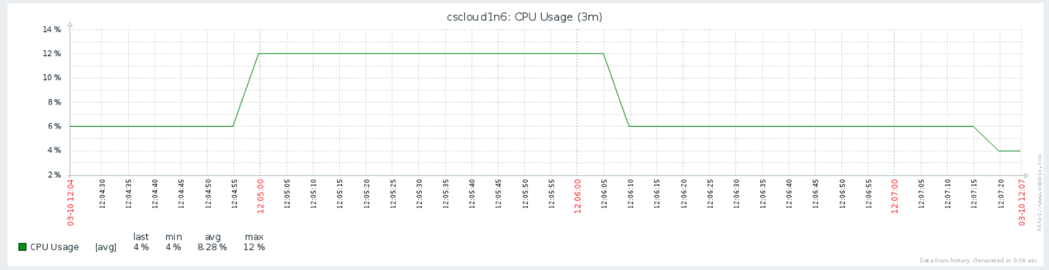

*Evidence of successful run, e.g. screenshot (4 marks)*

*Screenshots.*

**Any other comments:**